Java Basics

1. What is Java?
Java is a high-level, object-oriented, platform-independent programming language developed by Sun Microsystems (now Oracle).
It follows the principle Write Once, Run Anywhere (WORA).

Real-world example:
A banking application developed in Java can run on Windows, Linux, and macOS without code changes.

2. JVM, JRE, JDK
JDK (Java Development Kit): Used by developers to write and compile Java programs.
JRE (Java Runtime Environment): Used to run Java programs.
JVM (Java Virtual Machine): Executes bytecode and provides platform independence.
1️⃣ What is JVM (Java Virtual Machine)?
Definition
JVM is a virtual machine that:
- Runs Java bytecode
- Converts bytecode into machine-level instructions
- Makes Java platform independent
📌 JVM is not a physical machine
📌 JVM is software

What JVM does internally?
- Loads .class file
- Verifies bytecode (security)
- Executes code
- Manages memory (Heap, Stack, GC)

JVM Real-World Analogy
- Java code → English
- JVM → Translator
- OS → Native language (Windows/Linux/macOS)

Important Point
👉 JVM is different for each OS
- Windows JVM
- Linux JVM
- macOS JVM
But bytecode is the same.

🔷 2️⃣ What is JRE (Java Runtime Environment)?
Definition
JRE provides the environment to run Java programs.
📌 Used by end users, not developers.

JRE Contains:
- JVM
- Core Java libraries
- Supporting files

When do you need JRE?
✔ You want to run a Java application
❌ You cannot develop Java programs

Example
- Running a Java-based banking app
- Running a desktop Java tool

🔷 3️⃣ What is JDK (Java Development Kit)?
Definition
JDK is a complete toolkit used to develop Java applications.
📌 Used by developers

JDK Contains:
- JRE
- JVM
- Compiler (javac)
- Debugger
- Development tools

What can you do with JDK?
✔ Write Java code
✔ Compile Java code
✔ Run Java code
✔ Debug Java code

Example
- Developing a web application
- Creating Android apps
- Building enterprise systems

🔁 Java Program Execution Flow (Step-by-Step)
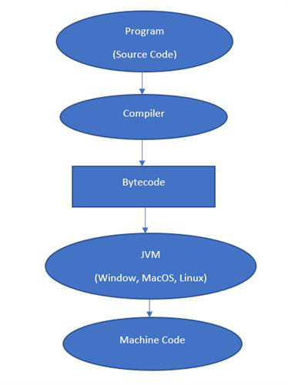
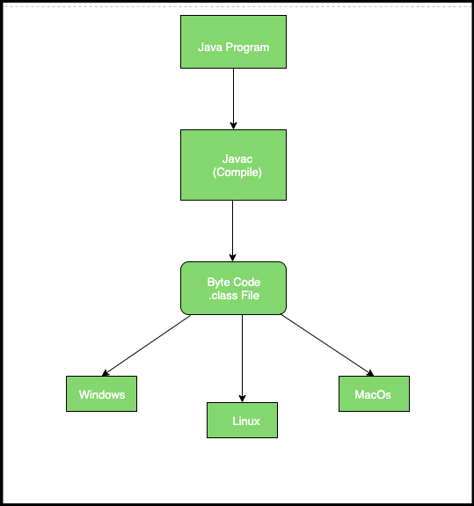
Step 1
Hello.java
Step 2 – Compilation
javac Hello.java
➡ Generates Hello.class (bytecode)
Step 3 – Execution
java Hello
➡ JVM executes bytecode

🧠 Relationship Between JVM, JRE, JDK
JDK
└── JRE
└── JVM
✔ JDK contains JRE
✔ JRE contains JVM
✔ JVM executes bytecode

📊 JVM vs JRE vs JDK – Differences Table
Feature | JVM | JRE | JDK
Full Form | Java Virtual Machine | Java Runtime Environment | Java Development Kit
Used By | System | End User | Developer
Purpose | Runs bytecode | Runs Java apps | Develops Java apps
Contains JVM | ❌ | ✔ | ✔
Contains Libraries | ❌ | ✔ | ✔
Contains Compiler | ❌ | ❌ | ✔
Can Write Code | ❌ | ❌ | ✔
Can Run Code | ✔ | ✔ | ✔

🎯 Interview-Friendly One-Line Summary
- JVM → Executes Java bytecode
- JRE → Environment to run Java programs
- JDK → Tools to develop Java programs

🏁 Final Conclusion
- If you are a user → JRE is enough
- If you are a developer → JDK is mandatory
- JVM is the heart of Java
Without JVM → Java cannot be platform independent.

3. Setup JDK
Steps:
Download JDK (Java 17 recommended)
Install JDK
Set JAVA_HOME
Add bin folder to PATH
Verify using java -version

4. Setup IDE – IntelliJ IDEA
IDE helps in writing, compiling, running, and debugging code.
Steps:
Install IntelliJ Community Edition
Create Java project
Select JDK
Run program

5. Primitive Data Types
Used to store simple values.
Examples: int, double, char, boolean
Real-world usage: age, salary, grade, status

6. Reference Variables
Store address of objects.
Example: String name = "Arun";

7. Control Flow – Conditional Statements
Used for decision making.
if, if-else, switch
Example: ATM PIN validation

8. Logical Operators
AND (&&), OR (||), NOT (!)
Example: Login validation

9. Mathematical Operators
+, -, *, /, %
Used in billing systems

10. Comparison Operators
==, !=, >, <, >=, <=
Used for eligibility checks

11. Arrays
Store multiple values of same type.
Example: Student marks list

12. Control Flow – Loops
for, while, do-while
Example: Printing salary slips

13. Commenting
Used to explain code.
Single-line and multi-line comments

14. Packages and Imports
Packages organize classes.
Imports reuse existing classes.

15. Debugging
Finding and fixing errors.
Types: Compile-time, Runtime, Logical
Tools: Breakpoints, Step execution

